NASIG FUN RUN
Thursday June 11, 2020 6:00 AM
Meet in the lobby of The Davenport Grand Hotel

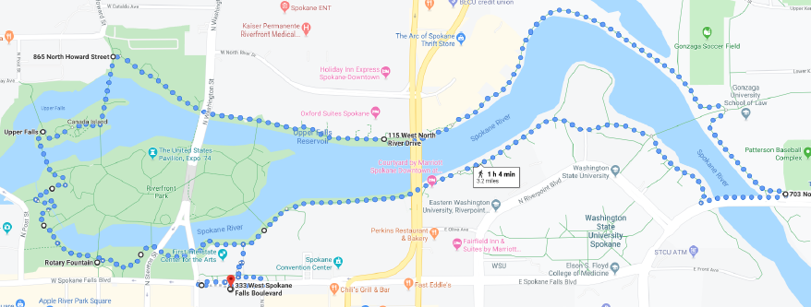

RELEASE WAIVER
I know that participation in the Fun Run is potentially hazardous activity, which could cause injury or death. By my signature, I certify that I am medically able to perform this event, and am in good health, and I am properly trained. I assume all risks associated with running in this event, including but not limited to: falls, contact with other participants, the effects of the weather, including high heat and/or humidity, traffic and all such risks being known and appreciated by me. Having read this waiver, for myself and anyone entitled to act on my behalf, waive and release the NASIG, its’ officers and members from all claims or liabilities of any kind arising out of my participation in this event, even though that liability may arise out of negligence or carelessness on the part of the persons named in this waiver.

PRINTED NAME: ________________________________

SIGNATURE: ___________________________________ DATE: ________________

Please complete and leave the waiver at the NASIG registration desk by the end of Conference Day Thursday, June 11.

