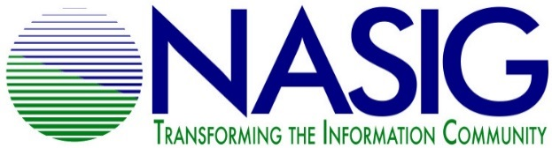
NASIG STUDENT MENTORING PROGRAM
2021 APPLICATION FOR MENTORS

Due May 1, 2021

Name: _____________________________________________________________
Workplace: __________________________________________________________
Title: _______________________________________________________________
Email address: _______________________________________________________
Phone number: __________________ Address: ____________________________
____________________________
Years of related experience: ________

Are you a member of NASIG?
Yes_____ No_____

The NASIG Student Mentoring Program requires a one year commitment of participation from mentors. This year’s program will run from June 2021 to May 2022. Will you be able to commit to this timeframe?
Yes_____ No_____
Why do you wish to serve as a mentor?

Areas of Expertise (Check all that apply.)
__ Cataloging/Metadata | __ Scholarly Communication
__ Technical Services | __ Public Services
__ Resource Sharing | __ Electronic Resources
__ Linked Data & Usability | __ Access & Discoverability
__ Collection Development/Assessment | __ Serials Management
__ Preservation/Digital Preservation | __ Open Access
__ Industry Standards | __ Licensing
__ Library Web Site Development | __ Accessibility/Diversity Initiatives
__ Usage Statistics | __ Institutional Repositories

Please list any other relevant areas of expertise that are not mentioned above.

Would you be able to mentor on research and publication?
Yes_____ No_____
Would you be willing to mentor on the school to work transition?
Yes______ No_____
Is there any other information that you would like to add to this application?

The NASIG Student Mentoring Programs plans to match one mentee with one mentor. However, if there is an excess number of mentee applicants, would you be willing to work with two mentees?
Yes_____ No_____
Please email your completed application by May 1, 2021 to daniellenasig@gmail.com
By submitting this form you aknowledge that you will actively participate in the program, will strive to be respectful and constructive in all communication. The Student Outreach Committee will be contacted if issues/concerns arise that the mentor or mentee are not able to resolve on their own. All discussions and information will be kept confidential unless otherwise specified by the both the mentor and mentee.

