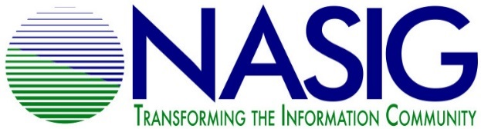
NASIG STUDENT MENTORING PROGRAM
2019 APPLICATION FOR STUDENT MENTEES

Due April 30, 2019

Name: _____________________________________________________________
University where studying library/information science: ___________________________________________________________________
Expected date for LIS degree: ___________________________________________
Email address: _______________________________________________________
Phone number: __________________ Address: ____________________________
____________________________
Are you a student member of NASIG?
Yes_____ No_____

Do you plan to attend the 2019 NASIG Conference? (attendance at the conference is not a requirement for being a mentee)
Yes_____ No_____

The NASIG Student Mentoring Program requires a one year commitment of participation from mentees. This year’s program will run from June 2019 to May 2020. Will you be able to commit to this timeframe?
Yes_____ No_____
See the program description for specifics about program participation.

Why do you want to be mentored? What would be your expectations of this program?

Areas of Interest (please choose up to 3):
__ Cataloging/Metadata | __ Scholarly Communication
__ Technical Services | __ Public Services
__ Resource Sharing | __ Electronic Resources
__ Linked Data & Usability | __ Access & Discoverability
__ Acquisitions | __ Serials Management
__ Collection Development | __ Open Access
__ Preservation | __ Licensing
__ Industry Standards | __ Print Serials
__ Library Web Site Development | __ Collection Assessment
__ Digital Preservation | __ Institutional Repositories
__ Preservation | __ Usage Statistics

Please list any other relevant areas of interest that are not mentioned above.

Would you like to be mentored on research and publication?
Yes_____ No_____

Is there any other information that you would like to add to this application?

Please email your completed application by April 30, 2019 to daniellenasig@gmail.com

