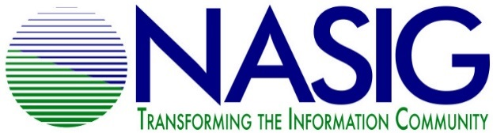
NASIG STUDENT MENTORING PROGRAM
2021 APPLICATION FOR STUDENT MENTEES

Due May 1, 2021

Name: _____________________________________________________________
University where studying library/information science OR first professional position/location: ___________________________________________________________________
Expected date for LIS degree: ___________________________________________
Email address: _______________________________________________________
Phone number: __________________ Address: ____________________________
____________________________
Are you a member of NASIG? (Required; student membership is free)
Yes_____ No_____

The NASIG Mentoring Program requires a one year commitment of participation from mentees. This year’s program will run from June 2021 to May 2022. Will you be able to commit to this timeframe?
Yes_____ No_____
See the program description for specifics about program participation.
Why do you want to be mentored? What would be your expectations of this program?

Areas of Interest (please choose up to 3):
___ Cataloging/Metadata ___ Scholarly Communication
___ Technical Services ___ Public Services
___ Resource Sharing ___ Electronic Resources
___ Linked Data and Usability ___ Access & Discoverability
___ Collection Development/Assessment ___ Serials Management
___ Preservation/Digital Perservation ___ Open Access
___ Industry Standards ___ Licensing
___ Library Web Site Development ___ Accessibility/Diversity Iniatives
___ Usage Statistics ___ Institutional Repositories

Please list any other relevant areas of interest that are not mentioned above.

Would you like to be mentored on research and publication?
Yes_____ No_____

Is there any other information that you would like to add to this application?

Please email your completed application by May 1, 2021 to daniellenasig@gmail.com
By submitting this form you aknowledge that you will actively participate in the program, will strive to be respectful and constructive in all communication. The Student Outreach Committee will be contacted if issues/concerns arise that the mentor or mentee are not able to resolve on their own. All discussions and information will be kept confidential unless otherwise specified by the both the mentor and mentee.

